# **TEAM BIOS**

**TEAM NAME:- CARBON**

**TEAM MEMBERS**

**Anoop P M**

**Software Engineer: Nest Digital**

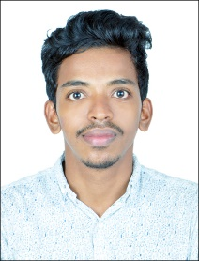

**John Christo**

**Software Engineer: Nest Digital**

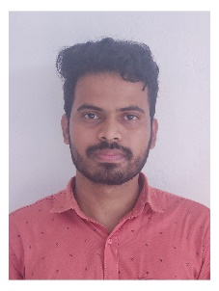

**Manu Fasil P M**

**Software Engineer: Nest Digital**

